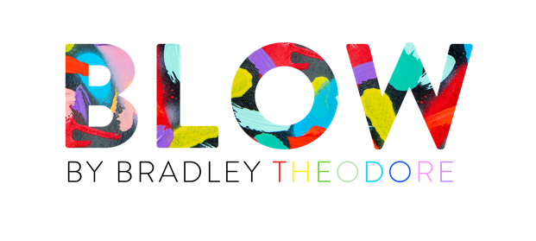
Street art meets luxury Italian craftsmanship in an immersive exhibition of one-of-a-kind Murano glass pieces transformed Bradley Theodore for Milan Design Week 2022

Milan, 6th June 2022 — For Milan Design Week 2022, Artemest presents BLOW: a collection of one-of-a-kind Murano glass pieces, made in collaboration with Bradley Theodore. Working side by side with the artist, the leading Murano glass masters created never-before-seen works of art, inspired by Theodore’s childhood in Turks & Caicos and revisiting familiar Caribbean themes such as starfish, lobsters, pineapples and corals.

The collision between Theodore’s highly charged creativity and the Murano makers’ time-honored expertise led to an eclectic, unexpected collection. At a time when everything boasts the signet of design – from a toothbrush to a work of art – American-based artist Bradley Theodore joined the Murano artisans as author and provocateur. The result is a curated collection which witnesses the idea that “clash” and “culture” are no longer at odds.

The show comes alive through Theodore’s kaleidoscopic lens, uncovering the many symbols of the Murano tradition – hand-embellished mirrors, Rezzonico chandeliers and souvenirs de Venise – side by side with the artist’s own color palette and childhood memories.

The exhibition features handcrafted, one-off pieces from nine glass masters, including:

- Fun Skull of Colors by Covi e Puccioni: two contemporary, backlit mirrors air sprayed by Bradley Theodore with his signature bright color palette
- Murano Meets Miami by Fornace Mian: a collection of 8 hand-carved Murano glass sconces, looking like “ghost skulls”
- Ocean and Spring by Fratelli Tosi: “his and hers” Murano glass mirrors, a pop art reinterpretation of Bradley Theodore’s childhood memories featuring a hand-painted skull and hand-engraved corals, starfish and Caribbean motifs
- Do You Like Pineapple Juice? chandelier by Luci Italia: a classic Rezzonico chandelier with a twist, featuring twelve pineapple-shaped lights
- Cosmic Flaming Frida by Multiforme: revisiting Bradley Theodore’s iconography, a laser-cut mirror in a rainbow of colors with a backlit halo of Murano glass
- Pop Skulls and Round Skulls by Ongaro & Fuga: a fun take on their “Cerchi” mirror, featuring a one-off ombré color palette and hand engravings of corals, fish, pineapples and palm trees
- Pineapple Dreams by Specchi Veneziani: a 2.5m-tall mirror handmade according to tradition, including hand-engravings with a diamond cutting sandstone wheel and rosettes decorations
- Vanitas by Venice Factory: a glass sculpture reinterpreting the traditional memento mori theme of the skull - seen through the centuries in Venetian art – rendering Bradley Theodore’ dynamic brush strokes with Murano glass inserts
- Cammarus by Vetralia: a sculptural mirror evocative of lobsters of the Antilles Caribbean Sea, engraved by hand on a painted wooden support.

1. 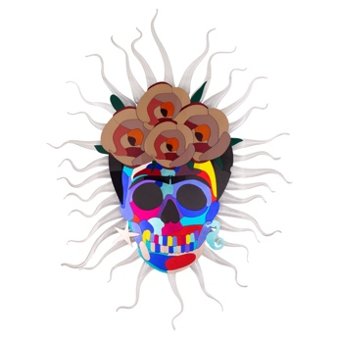2.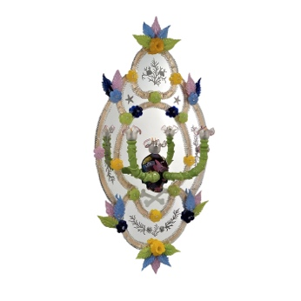3.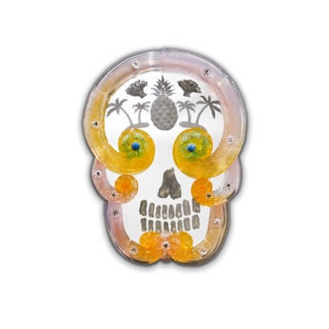
4. 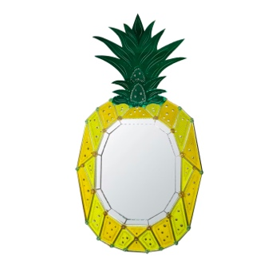5.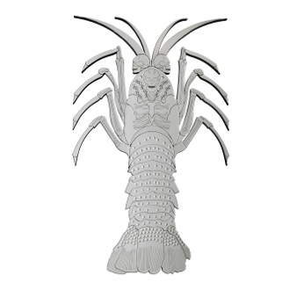6. 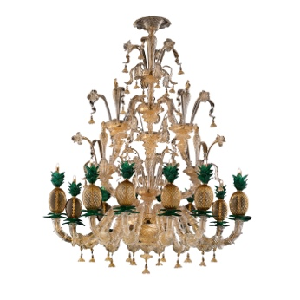

From top left: (1) Cosmic Flaming Frida by Multiforme, (2) Ocean by Fratelli Tosi, (3) Pop Skull Mirror by Ongaro & Fuga, (4) Pineapple Dreams by Specchi Veneziani, (5) Cammarus by Vetralia, (6) Do You Like Pineapple Juice? by Luci Italia

Address: Piazza San Marco, Giardino Roberto Sanesi – 20121 Milan
Press Preview: Monday 6th June (12pm – 6pm)
Press Cocktail and Dinner: Wednesday 8th June (7pm – midnight), by invitation

Public Opening:
Tuesday 7th – Friday 10th June (11am – 8pm)

High-res images available at this link

Press Contacts
EMEA / APAC: Artemest – press@artemest.com
US: CJ & Co. – cjuarez@cjandco.com
www.artemest.com

About Artemest
Artemest, the leading online marketplace for handmade luxury products made in Italy, was founded in 2015 by jewelry designer Ippolita Rostagno and manager Marco Credendino. Established to celebrate Italian craftsmanship, Artemest offers the unique opportunity to shop contemporary design in the categories of furniture, home décor, lighting and lifestyle. The selection of over 60,000 products is handmade by 1,300+ of the most representative Italian artisans and designers. Today, Artemest is based in Italy (Milan) and the United States (New York). The company ships to more than 70 countries around the world and has become the leading marketplace for the export of luxury made in Italy to North America and APAC.

About Bradley Theodore
Based between Miami Beach and New York City, Bradley Theodore is a multi- disciplinary artist whose iconoclastic approach to art can be found internationally, from 10-foot murals on the streets of New York, Tokyo, and Milan, to sold out solo exhibitions in London. With roots in graphic design, Theodore began his artistic career adorning the streets of New York City with vibrant, chromatic murals of skeleton crews depicting contemporary pop culture and fashion “royalty.” The artist has become a staple in the art and fashion scene across the globe.

